|  |  |
| --- | --- |
| **C:\Users\sit\Desktop\253207_214858558635429_402849015_n.jpg** | **SILIGURI INSTITUTE OF TECHNOLOGY**  **DEPARTMENT OF ELECTRICAL ENGINEERING**  **SILIGURI -734009** |



**Project On:**

**SCIENTIFIC CALCULATOR**

**By**

**ARICO DHAR**

**TAYAN SINGHA**

**ARNAB CHAKRABORTY**

**SUBHRAJIT DUTTA**

**PROSUN MAJUMDER**

Under the guidance of

**Siliguri Institute Of Technology**

## (Maulana Abul Kalam Azad University of technology (WBUT) )

**FACULTY OF EE DEPARTMENT**

## Certificate of Recommendation

This is to certify that <name of the student> has completed his project work titled “Minor project on: “Contact Book”, under the direct supervision and guidance of Ripam Kundu. We are satisfied with their work, which is being presented for the partial fulfillment of the degree of Bachelor of Technology (BTech), West Bengal University of technology (WBUT), Kolkata– 700032.

Signature Of TPO (Name of Teacher in charge of Project)

Date: Date:

Signature Of Director Arup Das

Siliguri Institute of Technology HOD EE Department (Siliguri Institute of Technology)

**Siliguri Institute Of Technology**

**FACULTY OF EE DEPARTMENT**

## 

## Certificate of Approval

The foregoing Minor project is hereby approved as a creditable study of Bachelor of Technology (BTech) and presented in a manner satisfactory to warrant its acceptance as a pre-requisite to the degree for which it has been submitted. It is understood that by this approval the undersigned do not necessarily endorse or any statement made, opinion expressed or conclusion therein but approve this Minor project only for the purpose for which it is submitted.

ARICO DHAR

TAYAN SINGHA

ARNAB CHAKRABORTY

SUBHRAJIT DUTTA

PROSUN MAJUMDER

Signature of the Members

Date :-

# 

# **TABLE OF CONTENTS**

* [Certificate of Recommendation](#_Toc114104999)
* [Certificate of Approval](#_Toc114105000)
* Abstract
* [Introduction](#_Toc114105001)
* Project Description
* [Snapshot](#_Toc114105004)
* [Conclusion](#_Toc114105005)
* [References](#_Toc114105006)

**Abstract**

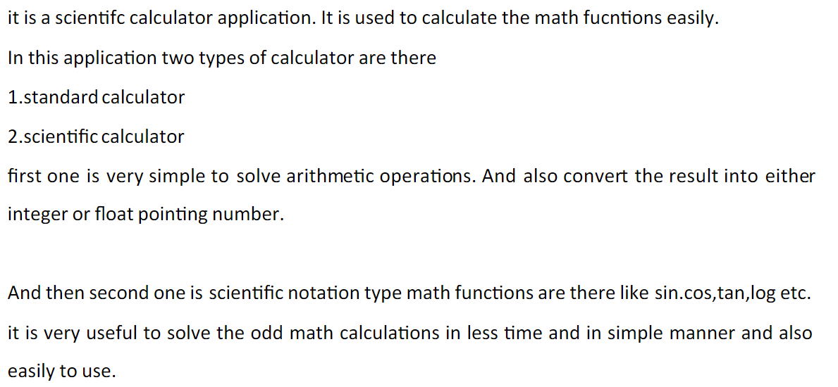

**Introduction**

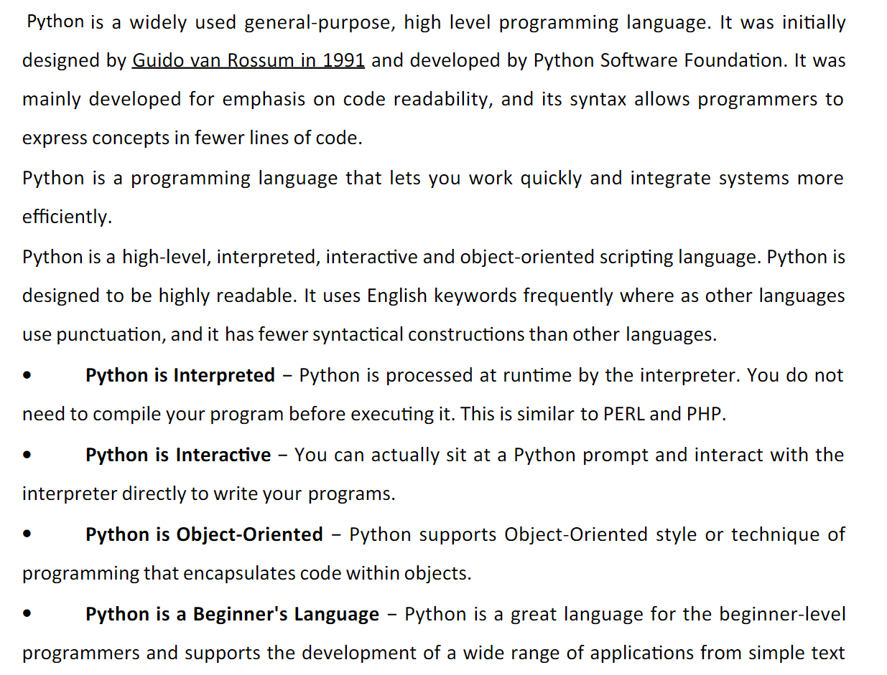

**Project Description**

**Python Tkinter Gui**

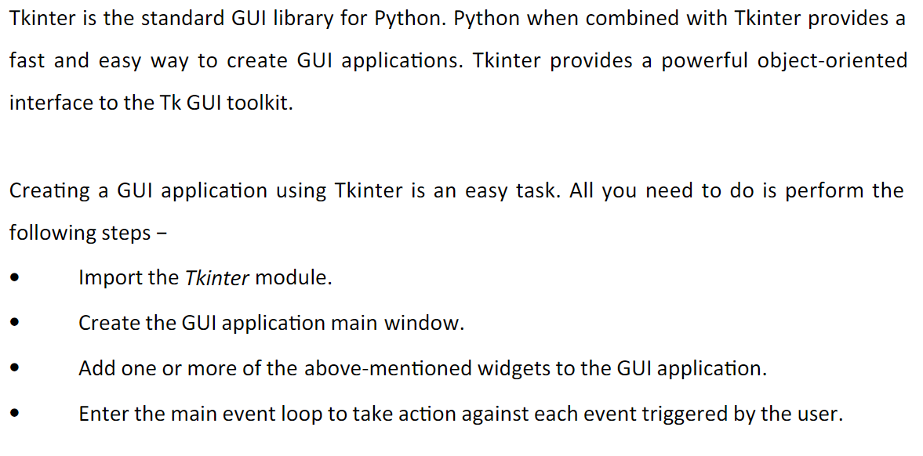

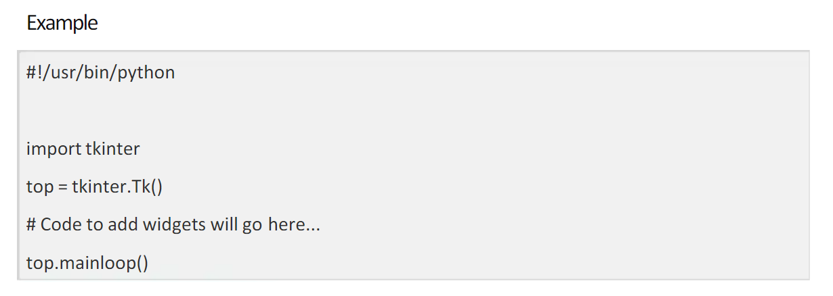

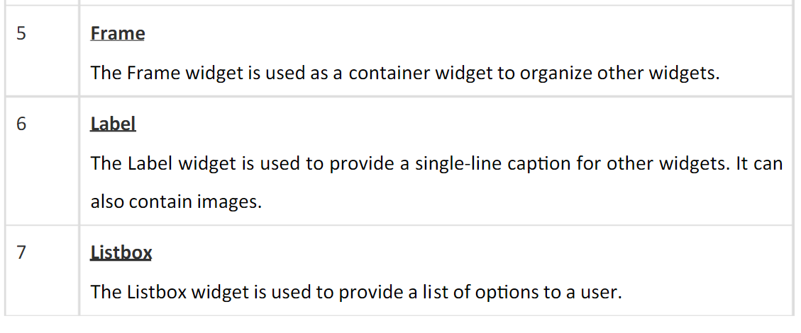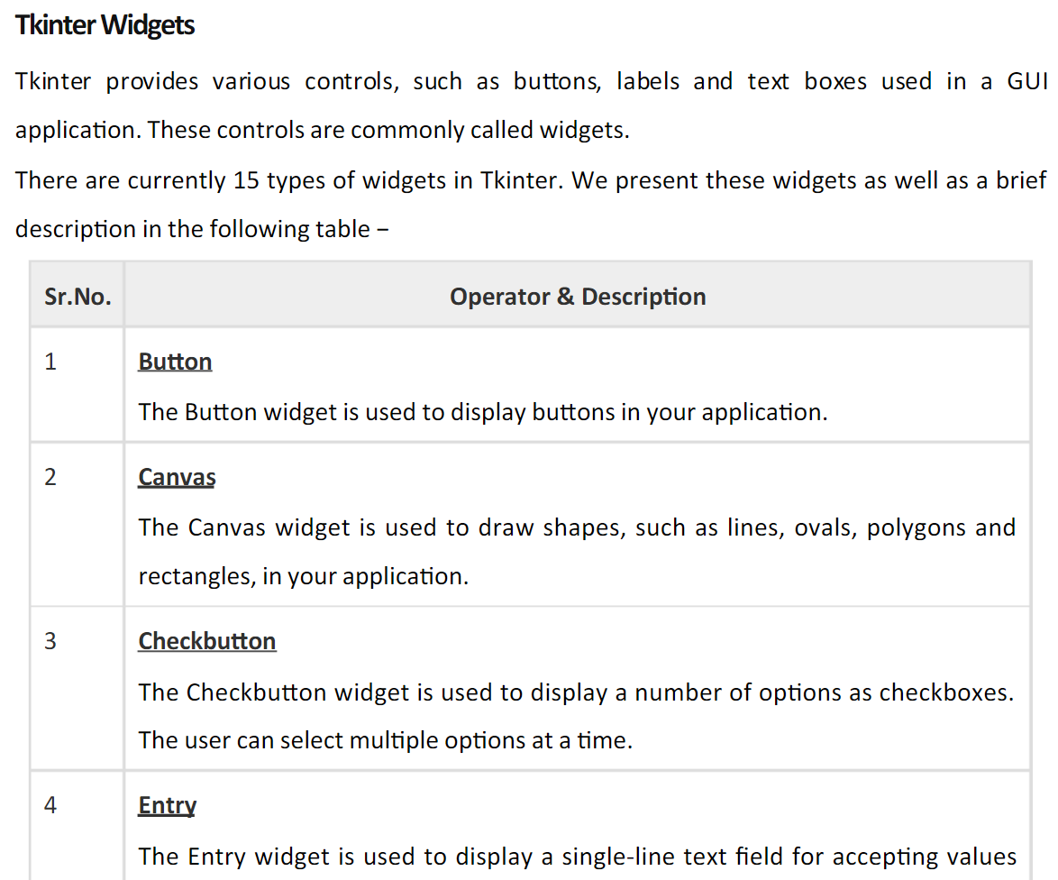

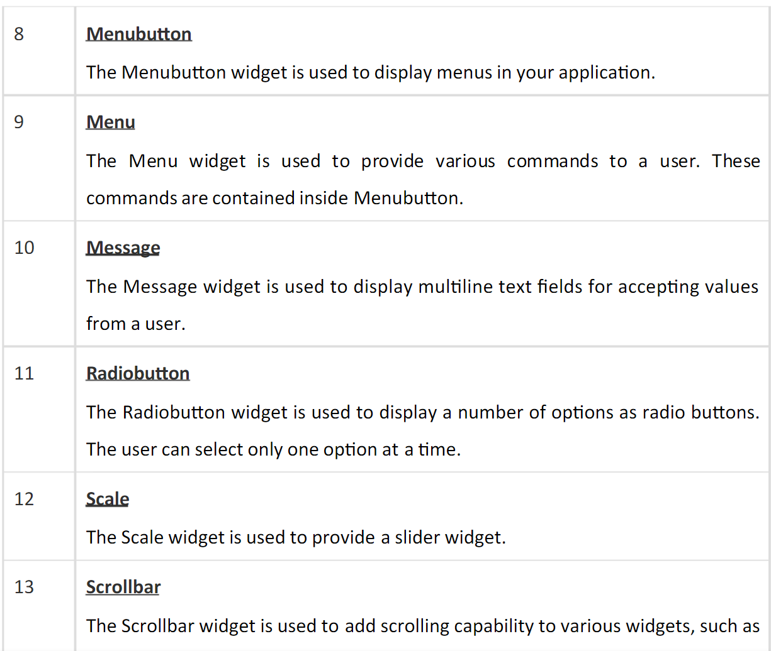**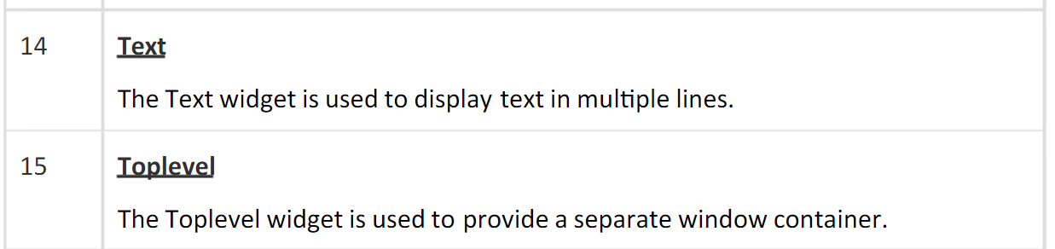**

Implementation

Language used :- Python

Code of project

from tkinter import \*

import math

def click(value):

ex=entryfield.get()

answer=""

try:

if value=="C":

ex=ex[0:len(ex)-1]

entryfield.delete(0,END)

entryfield.insert(0,ex)

return

elif value=="CE":

entryfield.delete(0,END)

elif value=="SQRT":

answer=math.sqrt(eval(ex))

elif value=="pi":

answer=math.pi

elif value=="cose":

answer=math.cos(math.radians(eval(ex)))

elif value=="sin":

answer=math.sin(math.radians(eval(ex)))

elif value=="tan":

answer=math.tan(math.radians(eval(ex)))

elif value=="2pi":

answer=2\*math.pi

elif value=="cosh":

answer=math.cosh(eval(ex))

elif value=="sinh":

answer=math.sinh(eval(ex))

elif value=="tanh":

answer=math.tanh(eval(ex))

elif value==chr(8731):

answer=eval(ex)\*\*(1/3)

elif value=="x\u02b8":

entryfield.insert(END,"\*\*")

return

elif value=="x\u00B3":

answer=eval(ex)\*\*3

elif value=="x\u00B2":

answer=eval(ex)\*\*2

elif value=="ln":

answer=math.log2(eval(ex))

elif value=="deg":

answer=math.degrees(eval(ex))

elif value=="rad":

answer=math.radians(eval(ex))

elif value=="e":

answer=math.e

elif value=="log10":

answer=math.log10(eval(ex))

elif value=="x!":

answer=math.factorial(ex)

elif value==chr(247):

entryfield.insert(END, "/")

return

elif value=="=":

answer=eval(ex)

else:

entryfield.insert(END,value)

return

entryfield.delete(0,END)

entryfield.insert(0,answer)

except SyntaxError:

pass

root=Tk()

root.title("Scientific Calculator")

root.configure(bg="grey")

# width , height ,distance from x-axis , distance from y-axis

root.geometry("680x486+100+100")

entryfield=Entry(root,font=("arial",20,"bold"),bg="silver",fg="black",bd=10,relief=SUNKEN,width=30)

entryfield.grid(row=0,column=0,columnspan=8)

button\_text\_list=["C","CE","SQRT","+","pi","cose","sine","tan",

"1", "2", "3", "-","2pi","cosh","sinh","tanh",

"4", "5", "6", "\*",chr(8731),"x\u02b8","x\u00B3","x\u00B2",

"7", "8", "9", chr(247),"ln","deg","rad","e",

"0",".","%","=","log10","(", ")","x!"]

rowvalue=1

columnvalue=0

for i in button\_text\_list:

button=Button(root,width=5,height=2,bd=2,relief=SUNKEN,text=i,bg="grey",fg="black",font=("arial",18,"bold"),

activebackground="red",command=lambda button=i:click(button))

button.grid(row=rowvalue,column=columnvalue,pady=1)

columnvalue+=1

if columnvalue>7:

rowvalue+=1

columnvalue=0

root.mainloop()

**Screenshots**

**1**

**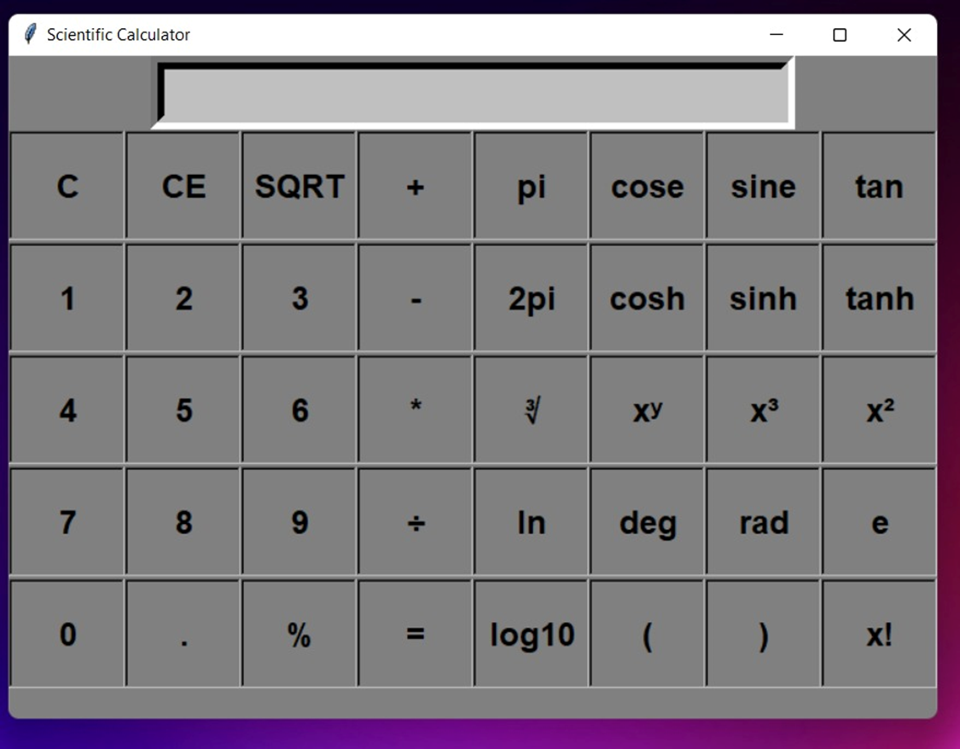**

Conclusion

